THE GUILD OF GCCF JUDGES & STEWARDS

GCCF GUIDANCE NOTES
FOR STEWARDS

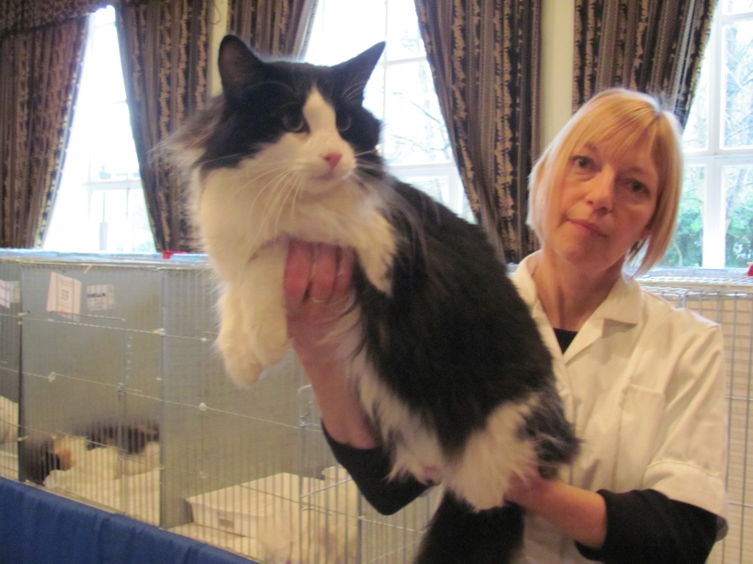

GCCF GUIDANCE NOTES FOR STEWARDS

STEWARDING ENGAGEMENTS
1. Stewarding engagements can be arranged through a Show Manager (preferably of a show run by a Club of which you are a member) or by a direct approach to a judge known to you. If these efforts fail, you should write to the Secretary of the Judges Guild who may be able to advise you further. It can be a good idea to take a white coat and a pen/pencil to a show and ask the Show Manager in the morning if any judge requires a steward. Do give some idea of your degree of expertise, always ask for advice if needed and be prepared to listen!
2. A good steward is of enormous help to a judge, but a bad one is a hindrance! Judges at shows are usually very busy and novices may be asked to act as second stewards on their first engagement. This should not be taken as a slight but will provide an excellent opportunity to learn as much as possible about the duties of a steward. Second stewards are usually asked to pay for their own lunch, as Clubs cannot always afford to finance more than one steward.
3. If an engagement is booked a number of weeks/months in advance (e.g. at a previous show), it can be helpful to confirm with the judge you are still available on that day and look forward to the show. It is a good idea to do this about a week before the show in question.
4. If GCCF Stewarding Certificates are being collected, the judge should be told before the start of judging.
5. If any of your cats has received a show rejection under Section C or D, you will not be allowed to steward until a GCCF clearance certificate has been received.
6. It is a GCCF Rule that stewards may not exhibit in a Breed Class (including cats to be considered for Best of Breed only), Grand, Imperial Grand, UK Grand, Olympian or Assessment Class which is to be judged by the judge for whom they are stewarding. It is important to check this well in advance and also again on show day. You are not allowed to stand down from stewarding just for that class, you are not allowed to steward at all for a judge you are showing under in one of the above classes. It is important to check this in advance and also again on show day in case of any class changes allocated to your judge. Should this situation arise on the morning of the show, you should notify the Show Manager immediately so that a change of stewards can be arranged.
7. Stewards should let the judge and the show manager know immediately if they are unable to fulfil an engagement.
8. The GCCF Stewarding Rules should be studied carefully before embarking on a stewarding engagement. It is also valuable to read any special rules regarding the show that may have been published in the schedule. Show Managers sometimes issue instructions to stewards on show day; these should be read carefully before the commencement of judging.

WORKING AS A STEWARD – DUTIES AND DEMEANOUR
9. Physical stamina is needed by stewards as the work is hard and requires you to be on your feet all day.
10. A steward should wear a clean white overall with pockets and no articles should be worn that might alarm or harm cats. Mobile phones should be on 'silent' and should not be used in the show hall. Equipment that may prove useful includes: ball point pens; pencils with rubbers; pencil sharpener; tippex pen; pen suitable for signing certificates and a copy of the schedule. Stewards are responsible for their own belongings during the day.
11. A ruled chart should be prepared before the show, to be used for recording the numbers of the winning cats in each class to enable a check to be made in order to prevent cross judging (see 18 below for a definition of cross judging). Many shows do provide stewards sheets, but this cannot be guaranteed. A template for a steward’s chart is available on the Guild website. A clip board is not recommended.
12. Judges are not expected to enter the show hall until it has been cleared of exhibitors and stewards should not take the Judge’s book into the hall to check for absentees before judging begins as that can be misunderstood by exhibitors.
13. It is the steward's responsibility to make sure that the necessary equipment is ready for the judge, including a trolley and disinfectant. There may also be lunch tickets and other vouchers to be kept during the day. The steward should listen to any messages given out over the tannoy system and should see that the judge hands in any paperwork required by the management when it is called for. Make sure the judge’s expense sheet and any requirements regarding taxis to the station etc. are handed in to the appropriate person before judging begins.
14. The ability to concentrate on the job is very important, as the judge should be able to rely on their steward to be ready and alert at all times. The temptation to chatter to the judge, other stewards and particularly to bystanders must be resisted. Stewards should not express their own opinion of an exhibit at or after a show unless invited to do so by the Judge or the owner.
15. Stewards must be tactful and polite to the judge, show officials and to exhibitors. An effort should be made to appreciate why the judge arrived at his or her placings in the different classes and most judges are willing to assist their stewards to understanding their placings by talk through their judging. These comments must be treated as confidential as complete trust between a judge and his/her steward is essential. If approached for information regarding the judge's opinion of an exhibit, a steward must always refer the exhibitor to the judge concerned, reminding exhibitors not to approach the judge until his/her judging has been completed. Never give others the results of a class before it has been displayed on the award board. Even after the engagement is completed a steward should never repeat any comments made by their Judge regarding exhibits and placings.

RESPECT AND CARE OF/FOR CATS
16. Stewards are responsible for other people's cats and must learn to handle them correctly and confidently, so that exhibits are not frightened when they are removed from the pen. Ask your judge how they like cats presented. They should be handled gently and not scruffed (unless it is an essential emergency measure either to prevent the cat from escaping or in self-defence). People who are nervous or hesitant when handling cats will not make good stewards as it is occasionally necessary to keep hold of a frightened cat in difficult circumstances. In the event of the cat causing any injury, great care should be taken to cover wounds quickly to prevent spillage of blood until such time as the wound can be washed thoroughly and treated appropriately. Suitable medical opinion should be sought as soon as possible if you have any concerns about your injury. Show Managers have a letter that can be taken to a doctor.

17. If a cat is nervous approach it quietly but with confidence. Try to take it out of the pen rear end first, stand it on the trolley with the cat’s head facing the open pen door. Never have direct eye to eye contact with a nervous or difficult cat; that is regarded as confrontational behaviour by a cat. Judges rely upon their steward to take the cat from the pen and place it on the trolley for judging in a way which causes the cat as little stress as possible. The trolley should be placed as near to the pen as possible in case the cat has to be returned quickly in an emergency. If the cat is sitting on a blanket it may be helpful to turn the blanket and draw it carefully to the pen door to enable the cat to be removed as easily as possible. When the cat is on the table do not let go until the judge has it safely held. Try not to let the cat see its neighbour during this time as this may upset it. Make sure that the door is kept open with no obstruction between cat and pen. Return the cat to the pen as soon as the judge indicates that they have finished judging it, settle it comfortably, making sure that the pen is properly fastened. Disinfect the trolley top and hands before moving to the next exhibit.

WORKING THROUGH THE DAY
18. When a class has been judged make sure that the judge has entered the results in all the sections of the judging book, including the correct certificate awarded or a note of the certificate or award being withheld, as appropriate. Make sure that the number of prizes offered for the class have been awarded and that the judge has signed the bottom of all the slips. Enter the results on your chart and check that no two cats have been placed in different orders in different classes (cross judging). Cats which have been judged in earlier classes are normally bracketed in the book (these are “repeats”) but DO NOT rely on this! When each class is completed take all the outer slips (still attached together) to the table immediately; if there is more than one page fold over a top corner to keep them together. The judge's attention should be drawn to any mistakes in the paperwork before it is taken to the table. It is vital that award slips are correct when they are taken to the table, as it is very difficult to correct errors at a later stage and much embarrassment and disappointment can be caused if mistakes remain undetected until after the results appear on the award board. If the show table is arranged in different sections, make sure you give your judge’s slips to the correct section.
19. Best of Breed (BOB) awards are offered at many shows and these results are normally entered on the breed class judge's slips. Often at the bottom of the Breed Class are cats listed for “BOB Only”, these should be considered before the judge makes the BOB award. Sometimes judges need to confer over these awards and a steward may be sent to find the other judge concerned. The BOB award is offered in three categories: adult, kitten and neuter. Cats to be considered for Best of Breed shall be winners of the breed class, provided that the certificate has been awarded, and cats of that breed that are entered in higher classes and are also to be considered as described above. The description "Best Opposite Sex" is sometimes given to the best cat of the opposite sex to the Best of Breed winner.
20. During the day your judge may be required to hand in Best in Show nominations (not all shows hold a Best in Show); try to ensure that this is done as soon as possible. Cats eligible for nomination for Best in Show are: Olympian, Imperial Grand Challenge, Grand Challenge, Challenge, Imperial Grand Premier, Grand Premier, Premier, Intermediate and Assessment winners and Best of Breed/Best Opposite Sex winners. Kitten breed class winners are eligible for nomination provided that Best of Breed, if offered, has not been withheld. The opposite sex kitten to the Best of Breed winner is also eligible for nomination provided that Best Opposite Sex, if offered, has not been withheld. Where kitten breed classes are split by age or colour, the winner of the split class is eligible for nomination provided that Best of Breed/Best Opposite Sex, if offered, has been awarded. This does not prevent Show Managers from restricting nominations to Best of Breed winners only.
21. When Best in Show judging is announced stewards whose judges have finished their engagement, or whose judge is taking part, should report at once to offer help. There are many different ways in which Best in Show is judged but if it is judged at a table, not in the pens, stewards should collect cats from their pens in their baskets as requested by the organiser and bring them to the table. After judging has taken place all unsuccessful cats should be returned quickly to their pens and the winner should be placed in the correct Best in Show pen.

22. When all the classes in the book have been judged and the judge has completed Best in Show (if involved), the steward should check to see if any special awards are to be decided. These awards often require consultation with judges who judged other relevant classes and are to decide on the winner of specific cups or prizes, e.g. for the Seal Point Siamese with the best eye colour. After this the steward should return the show equipment to the Show Manager and collect and check any certificates for signing. When they have been signed and returned, collect the judge's catalogue and volunteer to mark any classes the judge requires from the award board. When this has been done, ensure that the judge has transport to the station at the correct time (if required) before leaving.

GENERAL INFORMATION
23. Copies of the GCCF Rules and the Standards of Points book are obtainable from the GCCF Office. It is important to update these from time to time as new editions are published.
24. The GCCF Standards of Points booklet and initial membership to the Guild of GCCF Judges & Stewards are issued to candidates on application to join the GCCF Stewarding Scheme. Application Forms are available on the Guild Website; The GCCF Website; from the Guild Secretary or the GCCF Office.
25. A list of GCCF Shows is available on the GCCF Website at http://www.gccfcats.org/showsnew.html

FINALLY ……
If there is any aspect of the GCCF Stewarding Rules or Guidance Notes you do not understand or that you would like clarified, please contact the Secretary of the Guild for assistance via our website http://gccf-jasguild.weebly.com/ The Guild of GCCF Judges & Stewards is there to guide and support you through the scheme.
